AEPHY2024
Narrogin SHS Year 11 ATAR PHYSICS Name:
Task No: | 8b
Task Type: | Science Inquiry
Content: | Linear motion and force
Unit context: | Vehicle movement and collisions
Task Description: | Answer the following questions  In class (test conditions) 20 minutes
Total Marks: | 16
Weighting: | 6% (1.5% Take Home Component, 4.5% Validation Test)
Materials required | pens, pencils (including coloured), sharpener, correction fluid, eraser, ruler, highlighters, scientific calculator
Due Date:

- Complete the table below, including correct units. (10 marks)
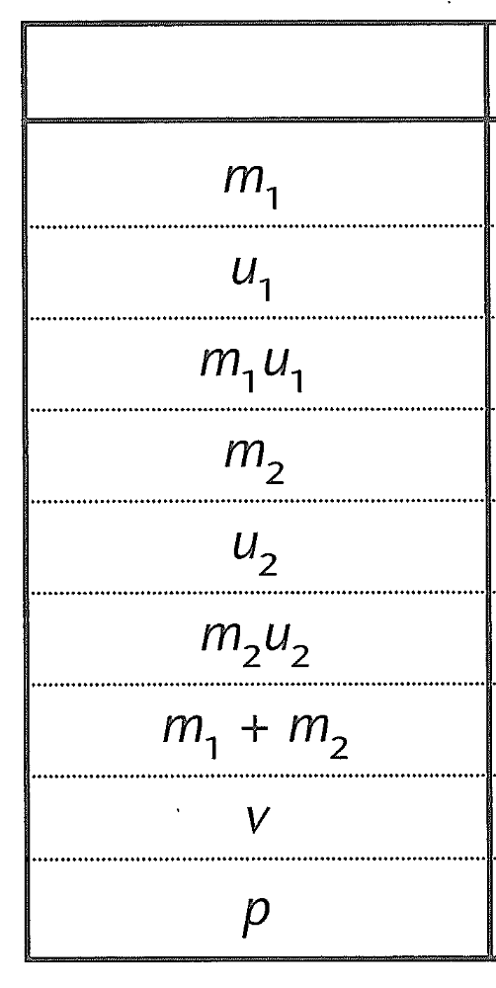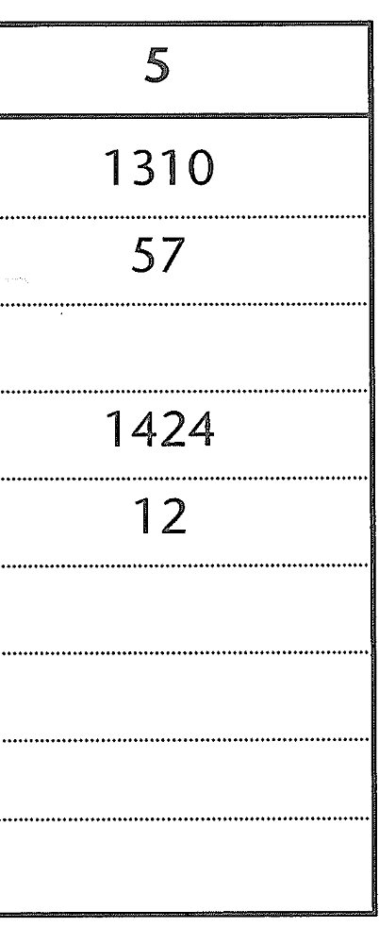
- Determine the acceleration for whiplash for the driver in the slower car (assume t=0.4s) (3 marks)

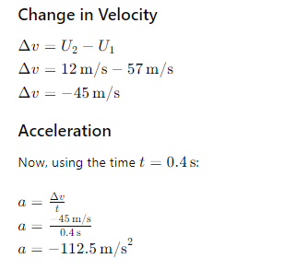

- Explain one factor that would need to be considered when designing a headrest (3 marks)

Sample Answer:
Position and Height of the Headrest
• Optimal Height (1 mark):
- The headrest should be positioned so that its top edge is at least as high as the top of the occupant's head. This ensures support for the head and neck, reducing the risk of hyperextension during a rear-end collision. A headrest that is too low can increase the likelihood of neck injuries by allowing the head to extend backward over the headrest.
• Proximity to the Head (1 mark):
- The headrest should be as close to the back of the head as possible, ideally within a few centimeters (about 2 inches). This proximity ensures that the headrest can effectively limit the rearward movement of the head in the event of a sudden stop or collision. A headrest that is too far from the head will not provide timely support, increasing the risk of whiplash.
• Adjustability (1 mark):
- Given that people have different heights and sitting postures, the headrest should be adjustable both vertically and, if possible, horizontally. This adjustability ensures that occupants can position the headrest to match their specific body dimensions and seating preferences. Properly adjustable headrests can accommodate a wide range of occupants, enhancing overall safety and comfort.

